**Variables in Java**

Variable is a name of a memory location.

Variable is name of reserved area allocated in memory.

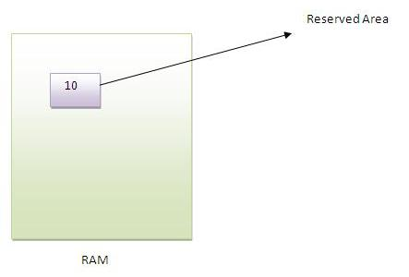

3 types of variables:

* Local: A variable that is declared inside the method
* Instance: A variable that is declared inside the class but outside the method
* Static: A variable that is declared as static  
   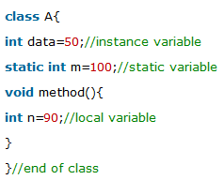
* We can declare a variable within one method of a class and use same variable name within another method of the class. But, we can’t use twice within same block.
* Locally declared variables always masks or hides another variable with the same name elsewhere in the class. Overrides: local variable takes precedence over other same name variables.

**Data Types in Java-** In java, there are two types of data types

* primitive data types: Boolean, Char, byte, short, int, long, float, double
* non-primitive data types: String, Array

